Scrum – Up!

User Manual

1. Creating an account

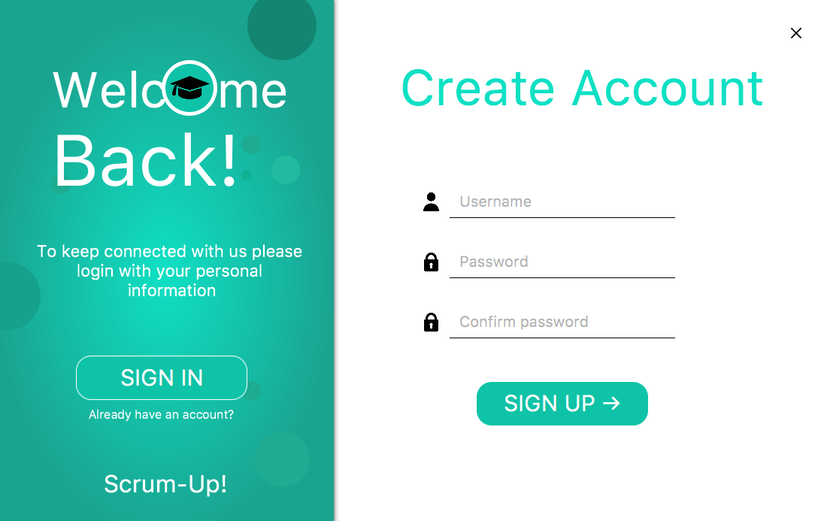

Step 4: Select “Sign up”

Step 1: Write your desired username

Step 3: Password confirmation needed

Step 2: Write your desired password

1. Log in



Step 1: Select “Sign in”

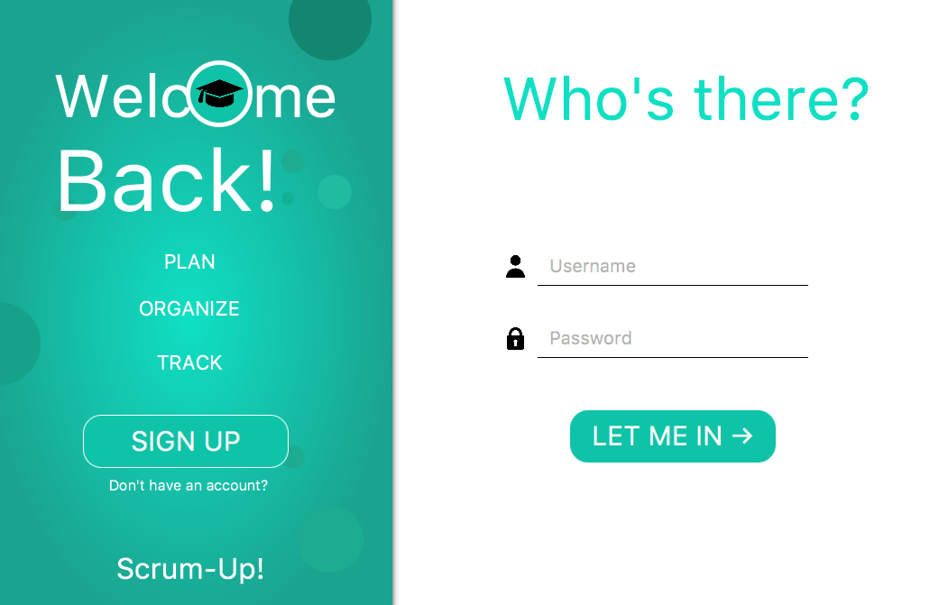

Step 4: Select “Let me in”

Step 3: Write your password

Step 2: Write your username

1. CREATE GROUP

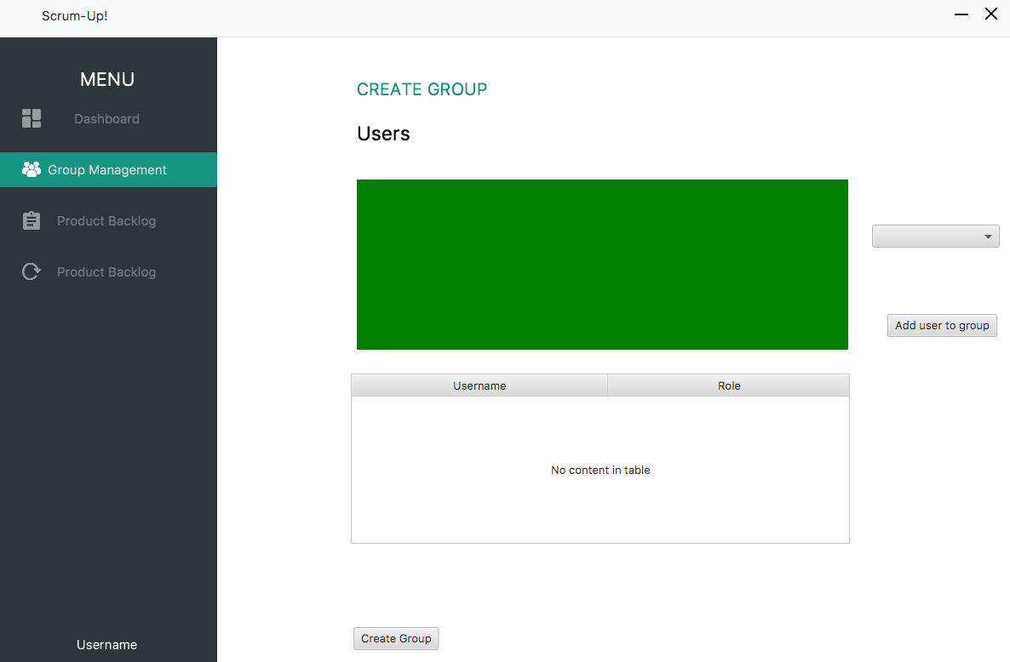

Step 1: Select Group Management

Step 4: Select “Create Group”

Step 3: Assign a role

Step 2: Select a user

1. Add new member to group

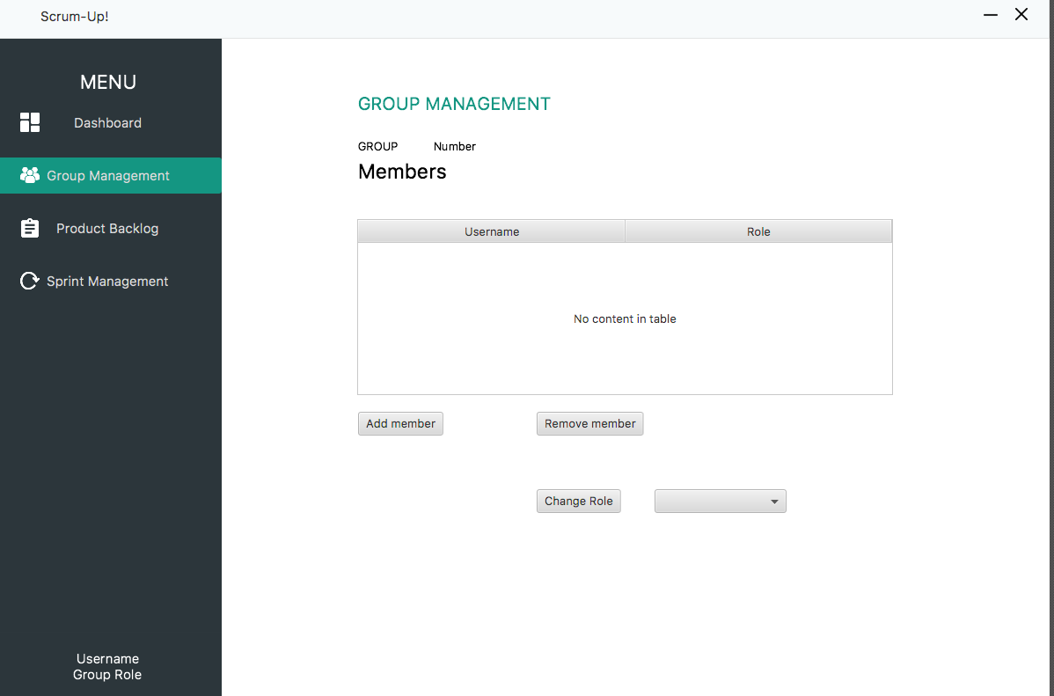

Step 2: Select “Add member”

Step 1: Select “Group management”



Step 5: Select “Add user to group”

Step 5: Select a role

Step 4: Select an user

1. Remove member from Group



Step 2: Select a group member

Step 3: Select “Remove member”

Step 1: Select “Group Management”

1. Change roles of team members



Step 4: Choose “Change role”

Step 3: Choose new role

Step 2: Select a group member

Step 1: Select “Group Management”

1. View current group



System will display all the team members and their assigned roles

Step 1: Select “Group Management”

1. Add User story to Product Backlog (includes view)

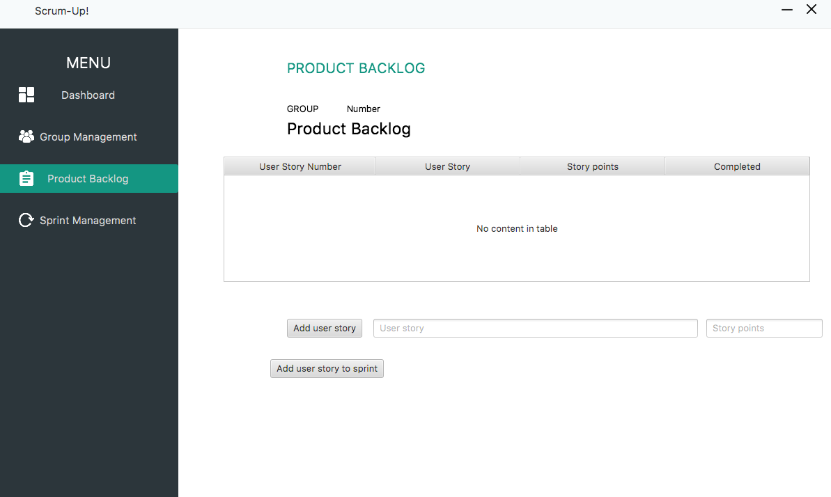

Step 4: Select “Add user story”

Step 3: Write the assigned story points

Step 2: Write the user story

Display of all the current user stories in the Product Backlog

Step 1: Select “Product Backlog”

1. Sprint: set number of Sprints, duration and active Sprint

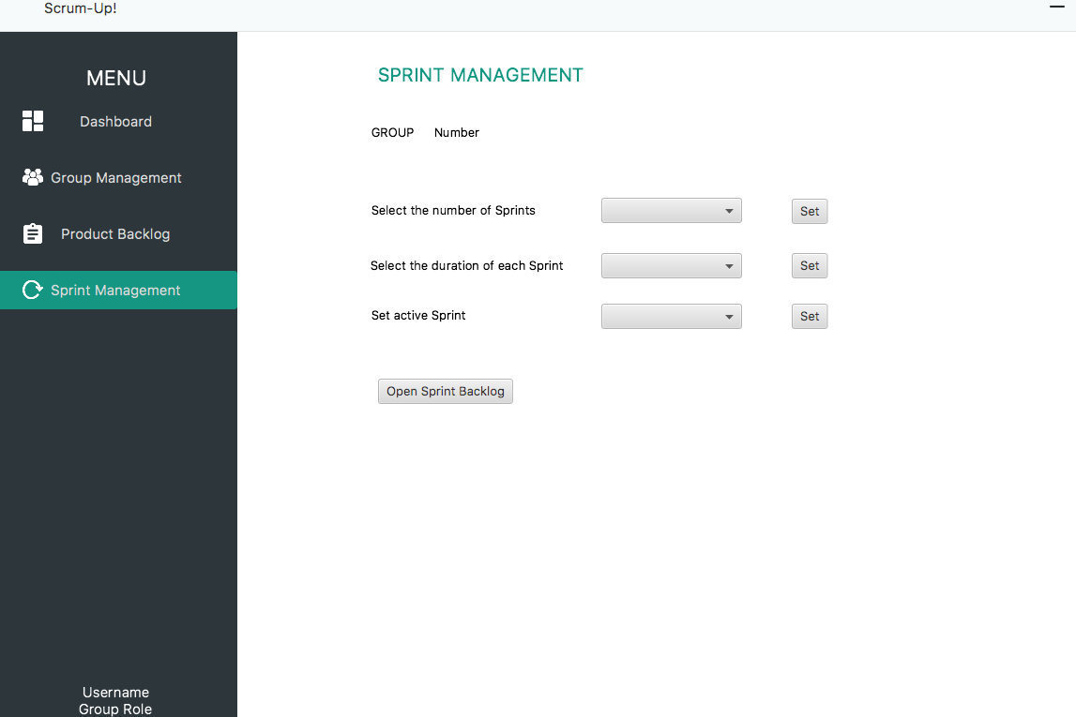

Step 2.2: Select active Sprint and press “Set”

Step 2.1: Select duration and press “Set”

Step 2: Select number and press “Set”

Step 1: Select “Sprint Management”

1. Add user story to Sprint Backlog



Step 2: Select a user story from Product Backlog

Step 3: Select “Add user story to Sprint”

Display of all the current user stories in the Product Backlog

Step 1: Select “Product Backlog”

1. View Product Backlog items and tasks

Step 2: Select current Sprint and select “Load sprint”

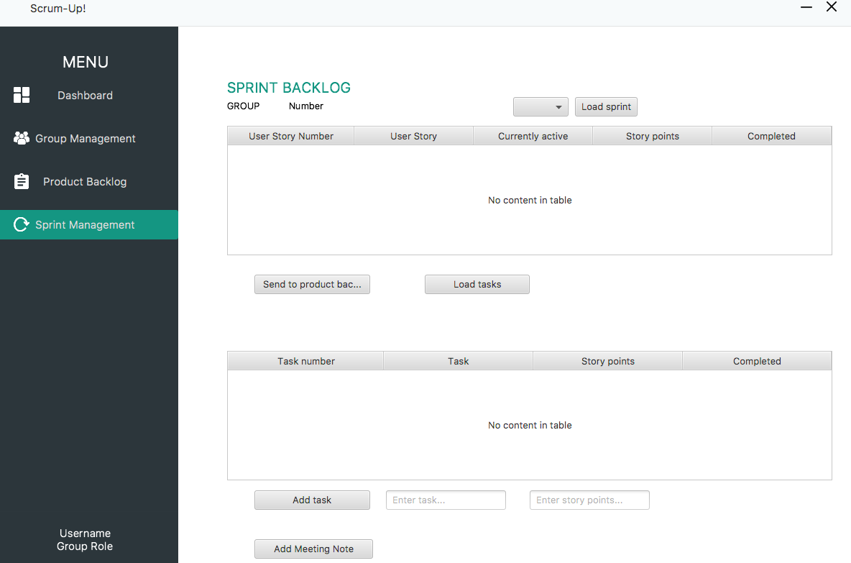

Step 3: Select “Load tasks”

Step 1: Select “Sprint Management”

1. Return Sprint Backlog Item to Product Backlog

Step 2: Select current Sprint and select “Load sprint”



Step 4: Select “Send to Product Backlog”

Step 3: Select item

Step 1: Select “Sprint Management”

1. Add tasks to Sprint Backlog

Step 2: Select current Sprint and select “Load sprint”



Step 4: Enter story points

Step 3: Enter task

Step 1: Select “Sprint Management”

Step 5: Select “Add task”

1. Add meeting notes



Step 2: Select “Add Meeting Note”

Step 1: Select “Sprint Management”

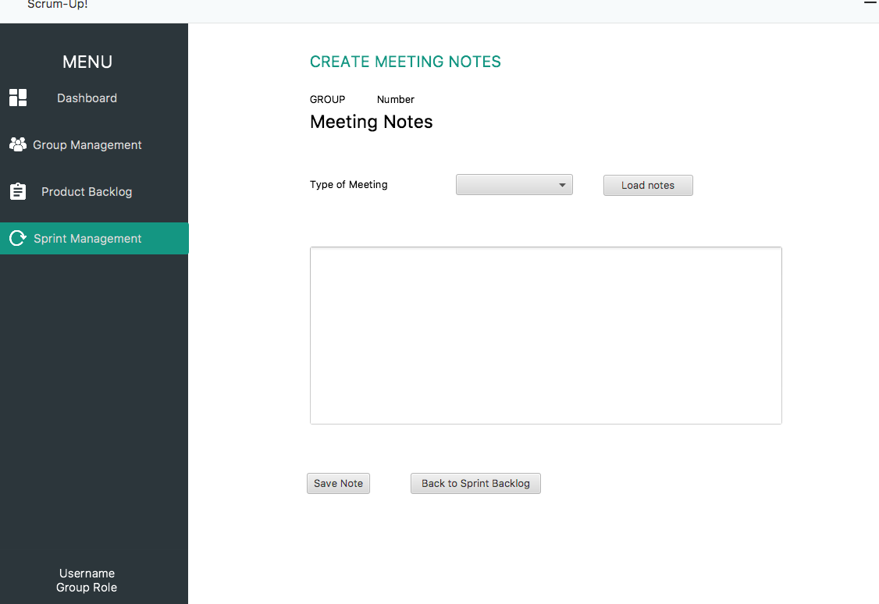

Step 5: Select “Save note”

Step 4: Enter notes

Step 3: Select “Type of Meeting”

1. View meeting notes



Step 2: Select “Add Meeting Note”

Step 1: Select “Sprint Management”



Step 5: Select “Back to Sprint Backlog” to return to Sprint Backlog

Step 4: Select “Load notes”

Step 3: Select “Type of Meeting”